**SPRINT GOAL:** By the end of this sprint, we should have a window in which we can add an item to an order, send the order to the server and **see it in the database**.

The sprint goal was achieved.

| PB-ID | ID | Task Title | Responsible | Estimate (hours) | Status |
| --- | --- | --- | --- | --- | --- |
| 1 | 1 | Design GUI | Robert + Kamil | 6 (3*2) | Completed |
| 1 | 2 | Implement Utility Package | Daniel + Laura | 4 (2*2) | Completed |
| 1 | 3 | Implement Model | Robert | 6 | Completed |
| 1 | 4 | Implement ViewModel (Includes making the ViewModelFactory + CustomerViewModel) | Robert | 6 | Completed |
| 1 | 5 | Implement View (Includes making the View Factory) | Kamil | 6 | Completed |
| 1 | 6 | Update Class Diagram | Robert + Laura | 4 (2*2) | Completed |
| 1 | 7 | Document MVVM | Robert + Kamil | 8 (4*2) | Completed |
| 1 | 8 | Test MVVM -> unit test for viewmodel | Robert + Kamil | 4 (2*2) | Completed |
| 5 | 9 | Add Class about database to Class Diagram | Daniel + Laura | 4 (2*2) | Completed |
| 5 | 10 | Implement Database Manager | Daniel + Laura | 32 (16*2) | Completed |
| 5 | 11 | Document Database Manager | Daniel + Laura | 4 (2*2) | Completed |
| 5 | 12 | Test Database Manager (properly documented -> integration test????) | Daniel + Laura | 8 (4*2) | Started |
| 5 | 13 | Implement RMI | Kamil | 2 | Completed |
| 5 | 14 | Document RMI | Kamil | 2 | Completed |

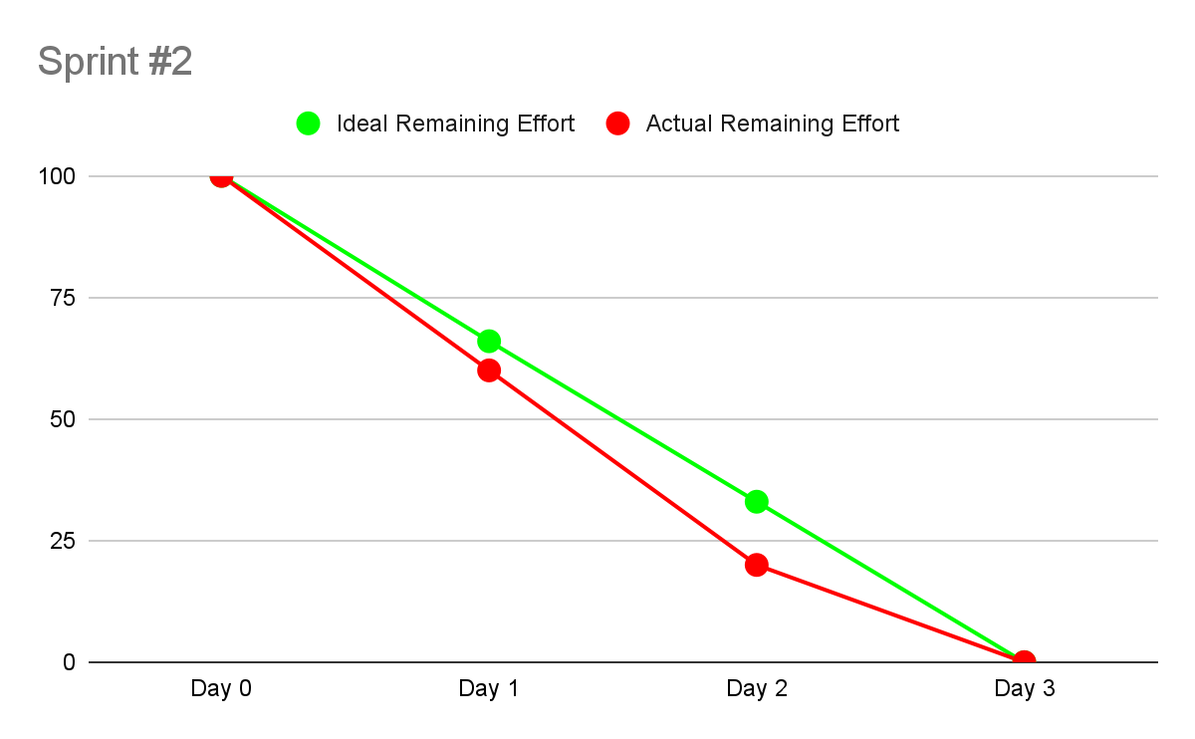

**WHAT WAS ACHIEVED:**

* everything we set out to achieve (window works, the methods go all the way from the view to the database)

**WHAT WENT WELL:**

* no major obstacles
* obstacles were overcome (GUI not opening, imports being weird)
* documentation is solid

**WHAT TO DO NEXT:**

* set up database for everyone
* make sure the new repository is working